WordPress
WordPress is an open source Content Management System (CMS), which allows the users to build dynamic websites and blog. WordPress is the most popular blogging system on the web and allows updating, customizing and managing the website from its back-end CMS and components

What is Content Management System (CMS)?
The Content Management System (CMS) is a software which stores all the data such as text, photos, music, documents, etc. and is made available on your website. It helps in editing, publishing and modifying the content of the website.

WordPress was initially released on 27th May, 2003 by Matt Mullenweg and Mike Little. WordPress was announced as open source in October 2009.

Features

- User Management − It allows managing the user information such as changing the role of the users to (subscriber, contributor, author, editor or administrator), create or delete the user, change the password and user information. The main role of the user manager is Authentication.
- Media Management − It is the tool for managing the media files and folder, in which you can easily upload, organize and manage the media files on your website.
- Theme System − It allows modifying the site view and functionality. It includes images, stylesheet, template files and custom pages.
- Extend with Plugins − Several plugins are available which provides custom functions and features according to the users need.
- Search Engine Optimization − It provides several search engine optimization (SEO) tools which makes on-site SEO simple.
- Multilingual − It allows translating the entire content into the language preferred by the user.
- Importers − It allows importing data in the form of posts. It imports custom files, comments, post pages and tags.

Advantages
- It is an open source platform and available for free.
- CSS files can be modified according to the design as per users need.
- There are many plugins and templates available for free. Users can customize the various plugins as per their need.
- It is very easy to edit the content as it uses WYSIWYG editor (What You See Is What You Get is a user interface that allows the user to directly manipulate the layout of document without having a layout command).
- Media files can be uploaded easily and quickly.
- It offers several SEO tools which makes on-site SEO simple.
- Customization is easy according to the user's needs.
- It allows creating different roles for users for website such as admin, author, editor and contributor.

Disadvantages
- Using several plugins can make the website heavy to load and run.
- PHP knowledge is required to make modifications or changes in the WordPress website.
- Sometimes software needs to be updated to keep the WordPress up-to-date with the current browsers and mobile devices. Updating WordPress version leads to loss of data, so a backup copy of the website is required.
- Modifying and formatting the graphic images and tables is difficult.

System Requirements for WordPress
- Database − MySQL 5.0 +
- Web Server −
  - WAMP (Windows)
  - LAMP (Linux)
  - XAMP (Multi-platform)
  - MAMP (Macintosh)
- Operating System − Cross-platform
- Browser Support − IE (Internet Explorer 8+), Firefox, Google chrome, Safari, Opera
- PHP Compatibility − PHP 5.2+

XAMPP
X CROSS PLATFORM
A APACHE SERVER
M MYSQL
P PERL
P PHP

Install Xampp : https://www.apachefriends.org/download.html
Note : not install in C: Drive
Now we can create project in wordpress
=======================================================================

Download WordPress

When you open the link https://wordpress.org/download/,

Now Download wordpress
Step : 1 Copy & paste wordpress folder in xampp/htdocs
Step : 2 xampp => xampp-control => strat server & mysql
go => xampp => xampp-control => open
start -> apache server
start -> mysql
Step : 3 go chrome => localhost/phpmyadmin
Mysql dashboard
Create Database for your wordpress project
  - New => create database => create
Step : 4 Setup wordpress now
Go chrome => localhost/wordpress

=====================================================================

Set Up Wizard
It's very easy to set up WordPress into your system. The following steps describe how to set up WordPress locally on your system.
Step (1) − Extract the downloaded WordPress folder and upload it into your web server or localhost.
Step (2) − Open your browser and navigate to your WordPress file path, then you will get the first screen of the WordPress installer as shown in the following screen. In our case, the path is localhost/< Your_wordpress_folder >.

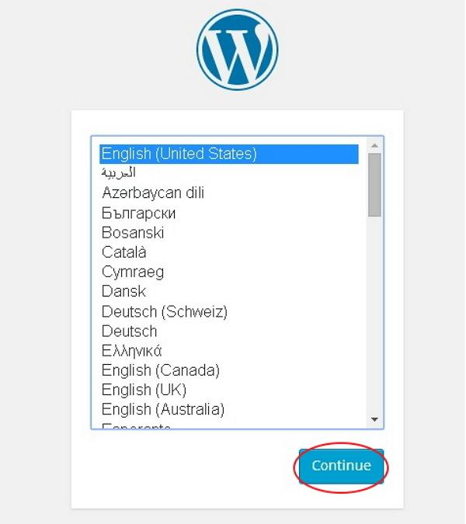
Select your language for the WordPress and click on Continue.
Step (3) − In this step, you can view the information needed for the database before proceeding with WordPress installation.
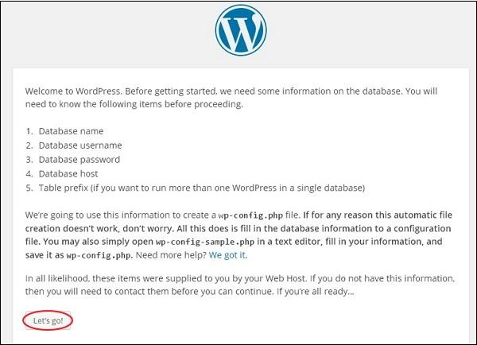
Click on Let's go!
AD
Step (4) − Here, you have to enter the information about the MySQL database as described in the following screen.
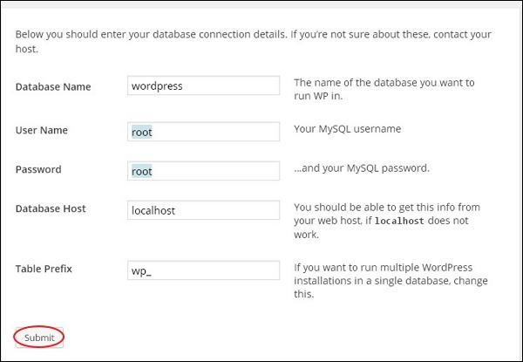
- Database Name − Enter the database name which you have created in MySQL database for WordPress.
- Username − Enter the user name of your MySQL database.
- Password − Enter the password which you had set for MySQL database.
- Database Host − Write the host name, by default it will be localhost.
- Table Prefix − It is used to add prefix in the database tables which helps to run multiple sites on the same database. It takes the default value.
After filling all information, click on Submit button.
Step (5) − WordPress checks the database setting and gives you the confirmation screen as shown in the following snapshot.
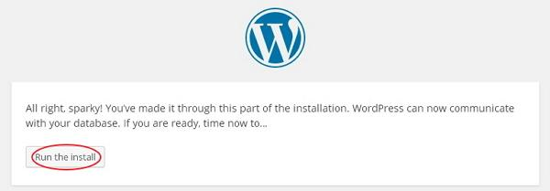
Click on Run the install
Step (6) − Enter administrative information.
AD
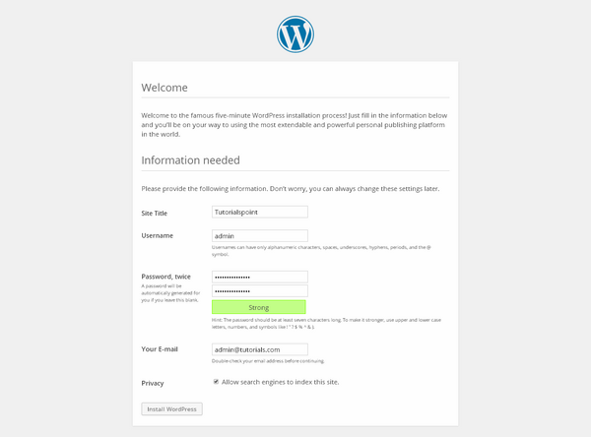
It contains the following fields −
- Site Title − Enter the name of the site which you are going to create in WordPress.
- Username − Enter the username as per your choice while logging in the WordPress.
- Password twice − Enter password two times to protect your site.
- Your E-mail − Enter your e-mail address which helps to recover the password or any update.
- Privacy − It allows the search engine to index this site after checking the checkbox.
After filling all the information, click on the Install WordPress button.
Step (7) − After installation being successful, you will get a screen of the stating success as seen in the following screen.
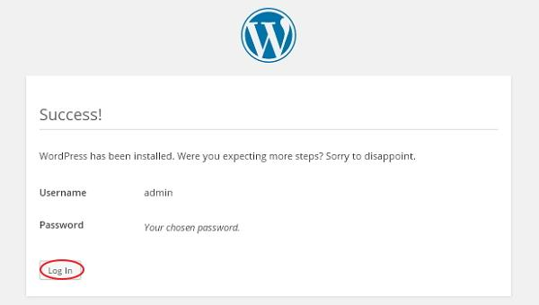
You can view your username and password detail added in WordPress.
Click on Log In button.
Step (8) − After clicking on login, you will get a WordPress Admin Panel as depicted in the following screen.
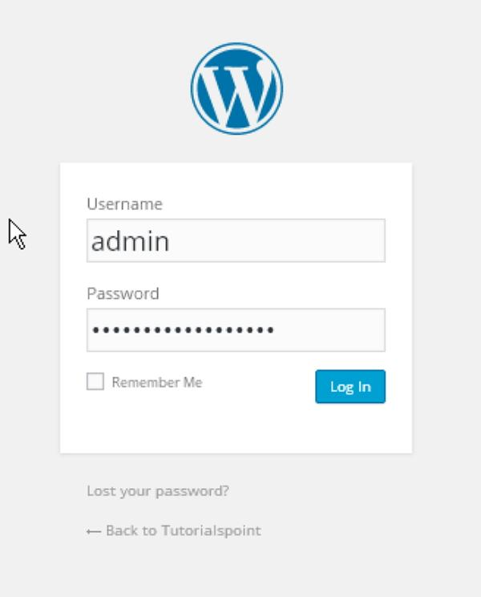
Enter the username and password which you had mentioned during installation as shown in step 6 and click on the Log In button.
Print Page

WordPress - Dashboard

The WordPress Dashboard is a first screen which will be seen when you log into the administration area of your blog which will display the overview of the website. It is a collection of gadgets that provide information and provide an overview of what's happening with your blog. You can customize your needs by using some quick links such as writing quick draft, replying to latest comment, etc.
Dashboard can be categorized as shown in the following snapshot. Each of these categories are discussed in the following sections −

Quick Draft
The Quick Draft is a mini post editor which allows writing, saving and publishing a post from admin dashboard. It includes the title for the draft, some notes about the draft and save it as a Draft.

WordPress News
The WordPress News widget displays the latest news such as latest software version, updates, alerts, news regarding the software etc. from the official WordPress blog.

Activity
The Activity widget includes latest comments on your blog, recent posts and recently published posts. It allows you to approve, disapprove, reply, edit, or delete a comment. It also allows you to move a comment to spam.

At a Glance
This section gives an overview of your blog's posts, number of published posts and pages, and number of comments. When you click on these links, you will be taken to the respective screen. It displays the current version of running WordPress along with the currently running theme on the site.

WordPress - Add Posts

Step (1) − Click on Posts → Add New in WordPress.
Step (2) − You will get the editor page of the Post as shown in the following screen. You can use the WordPress WYSIWYG editor to add the actual content of your post. Following are the fields on the editor page of the Add Posts Page.
- Post Title − Enter the title of the post, i.e., Post1.
- Post Content − Enter the content of your post.

Step (3) − Click on Publish button to publish your respective post.

- Save Draft − It saves the post as a draft.
- Preview − You can preview your post before publishing.
- Move to Trash − Deletes the post.
- Status − Change the status of your post to Published, Pending, or Reviewer Draft.
- Visibility − Change the visibility of the post to Public, Private or Password protected.
- Published − Change the publishded post date and time.

WordPress - Edit Posts

WordPress - Delete Posts

WordPress - Preview Posts

WordPress - Publish Posts

WordPress - Add Category

Step (1) − Click on Posts → Categories option in WordPress.

Step (2) − The Categories page is displayed as shown in the following screenshot.
Following are the details of the fields on Categories.
- Name − Enter the unique name of categories.
- Slug − A word chosen to describe your post. It is specified in the tags URL.
- Parent − By selecting the parent category from dropdown, you can set the particular category as sub-category or can keep it as None.
- Description − Add brief description of your category. It is optional.

Step (3) − After filling all the information about Categories, click on Add New Category button.
Step (4) − After clicking on Add New Category, the new created category will get displayed on the right side of the page as shown in the following screen.

WordPress - Edit Category

WordPress - Delete Category

WordPress - Arrange Categories
Step (1) − Click on Posts → Category Order in WordPress. The Category Order menu displays after adding the Category Order plugin.

WordPress - Add Tags
Tag is a small information attached to the main content or post for the purpose of identification. It tells the visitors what actually the post is about. If the tag is mentioned properly then it helps to find the content very easily.

WordPress - Media Library
In this chapter, we will learn about Media Library in WordPress. Media Library consists of the images, audios, videos and files that you can upload and add to the content when writing a Post or Page. Here you can view, add, edit or delete any media related objects if not needed.
Following are the steps to understand about Media Library.
Step (1) − Click on Media → Library in WordPress.
Note : if upload size 40MB then you can increase by manually
Go : Xampp/php/php.ini
post_max_size=1024M
upload_max_filesize=1024M

WordPress - Add Pages
In this chapter, we will study how to Add Pages into the WordPress. Adding pages is similar to adding posts in WordPress. Pages are static content and often do not change its displayed information.

Step (1) − Click on Pages → Add New as shown in the following screenshot.

WYSIWYG Editor
It is a WYSIWYG Editor, which is similar to a word processor interface where you can edit the contents of the article.
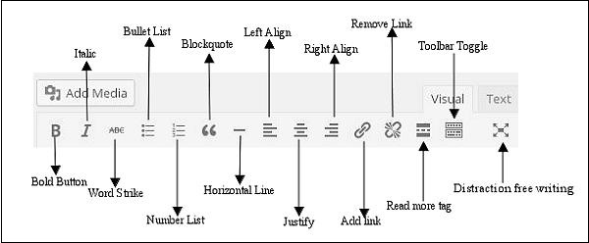
Following are the options present of WYSIWYG editor −
- Bold Button − Used to bold your font.
- Italic − Used to italicize the font.
- Word Strike − Strikes through the content.
- Bullet List − Adds bullets to content.
- Number List − Adds numbers to the list of the content.
- Blockquote − Quotes the text.
- Horizontal Line − Creates a horizontal line between sentences.
- Left Align − Sets the content on the left side of the page.
- Right Align − Sets the content to the right side of the page.
- Justify − Justifies the content of the page.
- Add Link − Adds a link to your content. When you click on this button, the following page gets displayed

